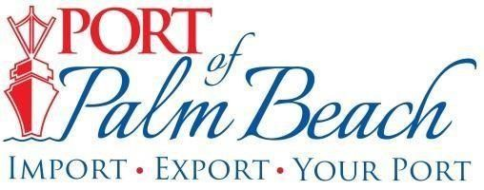
Media Contact
Yaremi Farinas OFFICE: 561-383-4138
Email
CELL: 561-319-0098

NEWS RELEASE

October 30, 2024
Click here to download photos

Port of Palm Beach Receives Award for Summer Internship Program

Riviera Beach, Fla.– This week, the Port of Palm Beach received a Lighthouse Award from the American Association of Port Authorities (AAPA) for excellence in administrative practices, specifically for its revamped Summer Internship Program.
Public Information Officer Yaremi Farinas and HR Manager Raquel Rivera received the award during the AAPA's Annual Convention in Boston. This is the first time the port receives an excellence award in the administrative practices category. Every year the AAPA, which represents more than 130 public ports in the U.S., Canada, the Caribbean and Latin America, recognizes programs and projects that stand out as a beacon of excellence across the port industry.
“We are honored to receive this recognition,” said Port of Palm Beach District Board Chairman Wayne M. Richards. “Our program encourages students from all academic backgrounds to explore diverse career opportunities, and we believe that this award validates our efforts to create meaningful experiences for our interns.”
The recognition is a testament to Port staff’s innovative approach and commitment to nurturing future leaders within the community.
“This initiative is truly a team effort,” Farinas said. “All department supervisors are actively involved in supporting our interns and providing them with the skills and knowledge they need to succeed in any field they choose.”
The eight-week paid program, funded primarily through donations from several port tenants, offers a wide range of opportunities across various fields, including accounting, finance, procurement, administration, communications, human resources, IT, port operations, engineering, planning, and tenant relations.

“Our commitment is to ensure that each intern leaves with not just work experience, but also confidence and a clear understanding of their potential,” Rivera said.
The Port will begin accepting applications for the 2025 Summer Internship Program in March 2025.

About Port of Palm Beach
Located in Riviera Beach, the Port of Palm Beach is a full-service, diversified port, offering cruise and cargo services to more than 30 onsite tenants and users. At 165 acres, the Port’s efficiency is unparalleled, processing more than $14 billion in commodities, 2.5 million tons of cargo, and 400,000 cruise passengers annually. As one of the largest employers in Palm Beach County, the Port of Palm Beach and its tenants employ more than 3,800 people. Through the contribution of more than $185 million in business revenue and $17.5 million in tenantcontributed state and local annual tax revenue, the Port of Palm Beach is a large economic engine in South Florida. The Port of Palm Beach District has not levied property taxes since 1975. For more information, visit www.portofpalmbeach.com.

###

