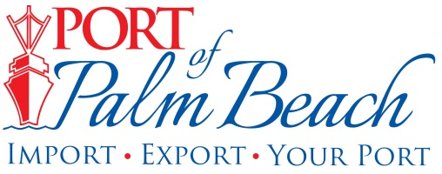
Media Contact
Yaremi Farinas
Email
OFFICE: 561-383-4138
CELL: 561-319-0098

NEWS RELEASE

July 1, 2024

Port of Palm Beach Executive Director Joins Riviera Beach Police Foundation Board of Directors

Riviera Beach, Fla.– The Riviera Beach Police Foundation has appointed Port of Palm Beach Executive Director Michael Meekins to its Board of Directors.

"I am honored to join the Board of Directors, allowing me to contribute to the nonprofit’s mission and objectives,” said Meekins.
The Riviera Beach Police Foundation, a nonprofit 501(c)(3) dedicated to supporting the Riviera Beach Police Department focuses on enhancing public safety through community partnerships, specialized training, and advanced technology initiatives.

"Mr. Meekins has blessed our Foundation with his commitment to provide his time and talent to ensure through fundraising that the Riviera Beach Police Department will have the most advanced training, the latest equipment and up to date technology so as to protect the community in the most effective way,” said Billie Brooks, Riviera Beach Police Foundation President.
Under Meekins leadership, in April 2024, the Riviera Beach Police Department assigned a full-time Riviera Beach Police officer to the Port to oversee both landside and marine operations.
"Joining this board allows me to apply my experiences and commitment to service in a meaningful way, ensuring my fellow board of directors and I uphold and strengthen public safety for all,” Meekins said.

About Port of Palm Beach
Located in Riviera Beach, the Port of Palm Beach is a full-service, diversified port, offering cruise and cargo services to more than 30 onsite tenants and users. At 165 acres, the Port’s efficiency is unparalleled, processing more than $14 billion in commodities, 2.5 million tons of cargo, and 400,000 cruise passengers annually. As one of the largest employers in Palm Beach County, the Port of Palm Beach and its tenants employ more than 3,800 people. Through the contribution of more than $185 million in business revenue and $17.5 million in tenant-contributed state and local annual tax revenue, the Port of Palm Beach is a large economic engine in South Florida. The Port of Palm Beach District has not levied property taxes since 1975. For more information, visit www.portofpalmbeach.com.

###

