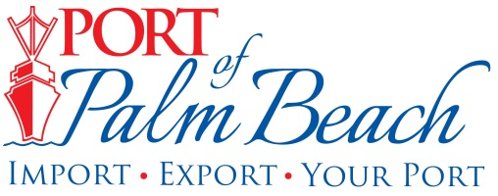
Media Contact
Yaremi Farinas
Email
OFFICE: 561-383-4138
CELL: 561-319-0098

NEWS RELEASE

March 11, 2024
Click here to download video

Port of Palm Beach Now Accepting Applications for
the 2024 Summer Internship Program

Riviera Beach, Fla.– Students in Palm Beach County are encouraged to apply for the highly anticipated Port of Palm Beach 2024 Summer Internship Program. Applications opened today, March 11th and will close on Friday April 26th.

“You do not necessarily need to be interested in the Port industry. We offer opportunities across a broad spectrum of industries,” said Port of Palm Beach District Board Chairman Wayne Richards.

The paid eight-week program offers opportunities in accounting/ finance/ procurement, administration, communications, human resources, information technology (IT), operations/engineering, planning, and tenant relations.

New this year, port tenant Ozinga, is looking for a student interested in learning how to operate the company’s cement terminal, ready- mixed concrete plant and work in the sales department.

“Our commitment to making a positive impact in our community extends beyond our products,” said Ozinga’s Vice President of Strategic Development Greg Vander Velde. “We believe in building a brighter future for the next generation of leaders who can carry our values forward.”

The program is a great opportunity for local students enrolled in university, college or a trade school in Fall 2024 to gain invaluable professional experience, regardless of their academic background or career aspirations.

By participating in Port of Palm Beach's Summer Internship Program, students will acquire transferable skills and industry insights that will serve them well in any professional setting.

“Last year, our interns not only contributed significantly to our projects but also became integral parts of our work family,” Meekins said. “This program isn't just about filling roles; it's about nurturing future leaders and fostering a culture of growth and development.”

The program is primarily funded through private monetary donations from numerous tenants including Ozinga, Tropical Shipping, South Florida Materials, E.N. Bisso & Son, Inc, Florida Sugar and Molasses Exchange.

For information on program dates, student criteria, application requirements, and the selection process, visit our website.

About Port of Palm Beach
Located in Riviera Beach, the Port of Palm Beach is a full-service, diversified port, offering cruise and cargo services to more than 30 onsite tenants and users. At 165 acres, the Port’s efficiency is unparalleled, processing more than $14 billion in commodities, 2.5 million tons of cargo, and 400,000 cruise passengers annually. As one of the largest employers in Palm Beach County, the Port of Palm Beach and its tenants employ more than 3,800 people. Through the contribution of more than $185 million in business revenue and $17.5 million in tenant-contributed state and local annual tax revenue, the Port of Palm Beach is a large economic engine in South Florida. The Port of Palm Beach District has not levied property taxes since 1975. For more information, visit www.portofpalmbeach.com.

###

