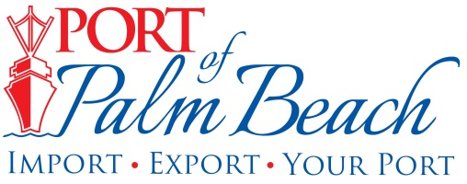
Media Contact
Yaremi Farinas
Email
OFFICE: 561-383-4138
CELL: 561-319-0098

MEDIA RELEASE
February 12, 2024

Port of Palm Beach Participating in Numerous Career Fairs to Promote Paid Summer Internship Program

Riviera Beach, Fla.– As the Port of Palm Beach gears up to open applications for its Summer Internship Program, port staff is scheduled to participate in a series of career fairs to promote the program.

“Our paid eight-week internship program is an essential steppingstone for students transitioning into the professional world and interested in gaining hands on experience,” Executive Director Michael Meekins said.

The first career fair staff is attending is at Nova University on Tuesday, February 13th, marking the beginning of an exciting recruitment drive.

During the next two months, Port staff plans to visit the following schools:

February 21: Florida Atlantic University
February 22: Riviera Beach Preparatory Academy
February 27: West Technical Education Center
March 14: Wellington High School
March 19: Lynn University
April 4: Sun Coast High School
April 9: Palm Beach State College
April 18: Palm Beach Gardens High School

With applications opening March 11th, students enrolled in university, college, or trade school, are encouraged to apply early due to the high volume of applicants anticipated this year.

“Last year’s program marked a significant milestone. We had the highest number of interns we have ever had, and we attracted qualified candidates who contributed to numerous projects,” Board Chairman Wayne Richards said.
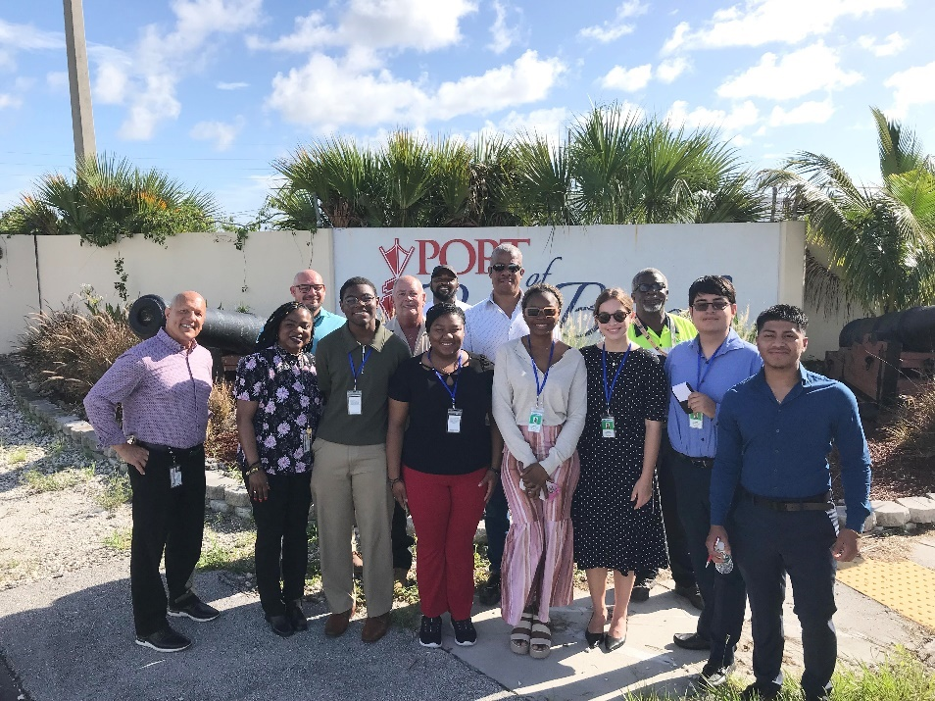

The 2024 Summer Internship Program offers opportunities across a broad spectrum of industries. Applicants can select to intern in finance/ accounting, administration, communications, engineering, information technology (IT), operations, planning, and tenant relations. New this year, port tenant Ozinga, is looking for a student interested in learning how to operate the company’s cement terminal.

For information on program dates, student criteria, application requirements, and the selection process, visit our website.

About Port of Palm Beach
Located in Riviera Beach, the Port of Palm Beach is a full-service, diversified port, offering cruise and cargo services to more than 30 onsite tenants and users. At 165 acres, the Port’s efficiency is unparalleled, processing more than $14 billion in commodities, 2.5 million tons of cargo, and 400,000 cruise passengers annually. As one of the largest employers in Palm Beach County, the Port of Palm Beach and its tenants employ more than 3,800 people. Through the contribution of more than $185 million in business revenue and $17.5 million in tenant-contributed state and local annual tax revenue, the Port of Palm Beach is a large economic engine in South Florida. The Port of Palm Beach District has not levied property taxes since 1975. For more information, visit www.portofpalmbeach.com.

###

