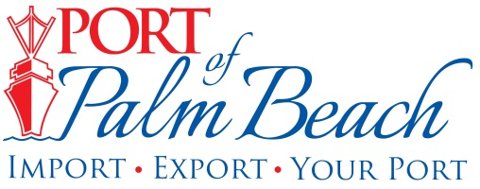
Media Contact
Yaremi Farinas
Email
OFFICE: 561-383-4138
CELL: 561-319-0098

MEDIA RELEASE
February 2, 2024

Port of Palm Beach Among Florida Ports
Seeing Cargo and Cruise Passenger Growth
Revenue Up A 22-Year-High

Riviera Beach, Fla.– On the heels of a recent report showing Florida’s system of seaports experienced record-high cargo growth, the Port of Palm Beach is among those Florida seaports experiencing milestones in ships calling on the port, as well as record revenue.

For the first time in more than a decade, all berths at the Port of Palm Beach were occupied on February 1, with container ships, cargo ships, a cruise ship, barges, and yachts occupying space. Occupied berth spaces equate to added revenue for the Port.

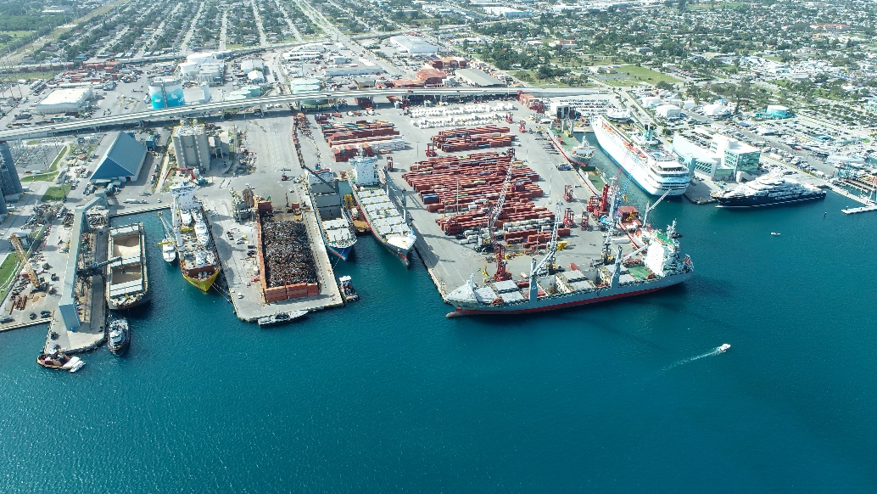

“This achievement is unheard of in my 22-year tenure as a Port Commissioner,” Port of Palm Beach Board of Commission Chairman Wayne Richards said. “Internal figures from Fiscal Year 2023 reveal we saw an 11 percent increase in net operating revenue, coupled with a seven percent reduction in operating expenses, resulting in a $4.8M total net income. That is a $3.3M increase from the FY 2023 budget. (Updated Feb. 6, 2024).

Richards credits the additional revenue to operational changes related to the cruise industry and strategic improvements in the cargo areas.

“Under the direction of Executive Director Michael Meekins, port staff identified innovative strategies to further boost the port’s revenue and ensure the Port of Palm Beach remains a primary economic engine in Palm Beach County, the state of Florida and the region,” Chairman Richards said.

In FY 2023, the Port of Palm Beach experienced cargo growth in:
Break-bulk,
Cement,
Sugar, and
TEUs (Twenty-foot Equivalent Units).

On the cruise side, the number of passengers traveling through Port of Palm Beach soared by 183 percent compared to prior fiscal year. The significant increase combined with changes in cruise operations, further added to the Port’s revenue success.

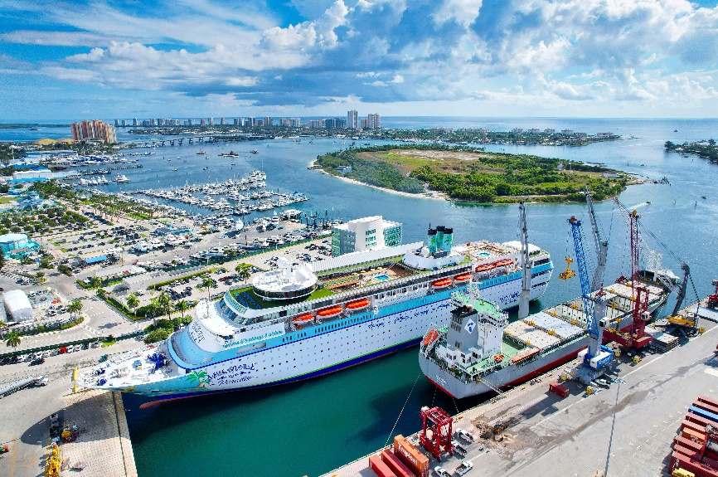

“As this year’s chair of the Board of Commissioners, I will continue to work with my fellow commissioners and the Executive Director to continue to drive our Port to new heights,” Chairman Richards said.

About Port of Palm Beach
Located in Riviera Beach, the Port of Palm Beach is a full-service, diversified port, offering cruise and cargo services to more than 30 onsite tenants and users. At 165 acres, the Port’s efficiency is unparalleled, processing more than $14 billion in commodities, 2.5 million tons of cargo, and 400,000 cruise passengers annually. As one of the largest employers in Palm Beach County, the Port of Palm Beach and its tenants employ more than 3,800 people. Through the contribution of more than $185 million in business revenue and $17.5 million in tenant-contributed state and local annual tax revenue, the Port of Palm Beach is a large economic engine in South Florida. The Port of Palm Beach District has not levied property taxes since 1975. For more information, visit www.portofpalmbeach.com.

###

