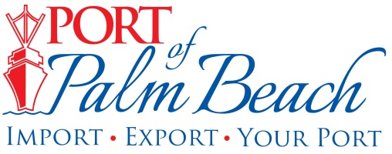
Media Contact
Yaremi Farinas
Email
OFFICE: 561-383-4138
CELL: 561-319-0098

MEDIA RELEASE
January 18, 2024

New Port of Palm Beach Board Chair Wayne Richards Aims to
Further Boost Port’s Revenue

Riviera Beach, Fla. – The Port of Palm Beach Board of Commissioners elected Wayne Richards as its new chair during the January 18th Board of Commissioners Meeting.
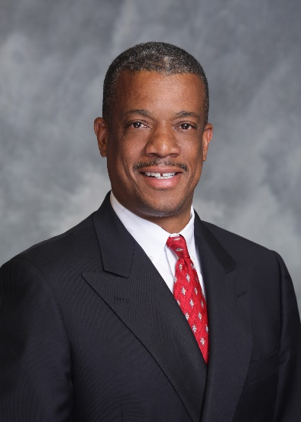
“I am honored to lead the Port into yet another year of revenue growth through our diverse maritime activities,” Richards said.

The Port of Palm Beach is an important distribution center for commodities shipped all over the world, Eighty percent of all cargo passing through the port is exported, primarily to the islands in the Caribbean.

“The Port of Palm Beach has been a key player in international trade since the early 1920’s. One of my goals as chair is to reestablish a cargo service benefiting our Haitian population in Palm Beach County,” Richards said.

The new business would boost the Port’s revenue and increase the Port’s cargo tonnage.

Richards says he is looking forward to seeing an increase in the number of cruise passengers traveling through the Port in 2024.

"The growth of cruise passengers is a testament to our and our cruise partner Margaritaville at Sea’s commitment to provide exceptional maritime experiences," Richards said.

Chair Richards is also focused on investing in port infrastructure. His strategy is to meet with current tenants and users to better understand the issues and impediments that impact their business.

“Open dialogue and collaboration are catalysts for propelling the Port and allowing the transportation hub to continue to serve as a powerful economic engine in Palm Beach County,’ Richards said.

A dedicated commissioner since 2001, Richards brings a wealth of experience in real estate, business law, land use, zoning, and governmental affairs to the chairman role. He earned a bachelor’s degree in mechanical engineering from Howard University and a law degree from the University of Michigan.

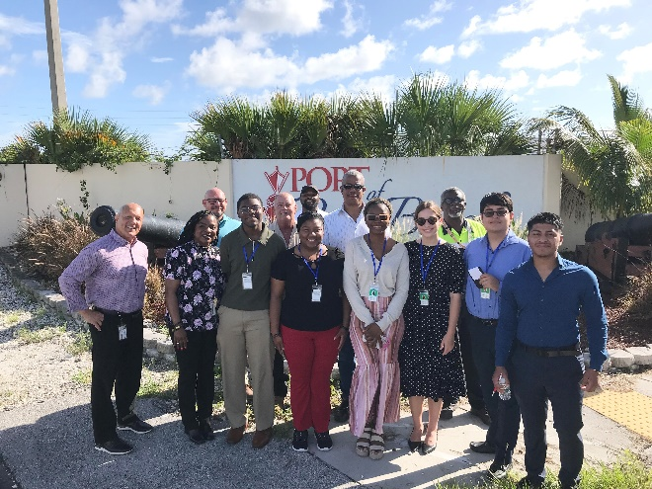
Beyond his professional endeavors, Richard’s commitment to community involvement aligns seamlessly with the Port's mission to be an integral part of the local community. Richards is a graduate of Leadership Palm Beach County and is a member of the Palm Beach County Bar Association, National Association for the Advancement of Colored People (NAACP), and Caribbean-American for Community Involvement (CAFCI). Richards played a key role in bringing back the Port of Palm Beach Summer Internship Program.

“I believe providing invaluable experiences to the next generation shows our commitment to our local community. We want to see our children building careers here in Palm Beach County,” Richards said.

Richards, a family man, enjoys quality time with his wife, Elrika, and their two daughters.

During Thursday’s Regular Board of Commissioners meeting, the board elected Dr. Deandre Poole as Vice Chair and Blair Ciklin as Secretary/ Treasurer.

Click here to learn more about each member of the Port of Palm Beach District Board of Commissioners.

About Port of Palm Beach
Located in Riviera Beach, the Port of Palm Beach is a full-service, diversified port, offering cruise and cargo services to more than 30 onsite tenants and users. At 165 acres, the Port’s efficiency is unparalleled, processing more than $14 billion in commodities, 2.5 million tons of cargo, and 400,000 cruise passengers annually. As one of the largest employers in Palm Beach County, the Port of Palm Beach and its tenants employ more than 3,800 people. Through the contribution of more than $185 million in business revenue and $17.5 million in tenant-contributed state and local annual tax revenue, the Port of Palm Beach is a large economic engine in South Florida. The Port of Palm Beach District has not levied property taxes since 1975. For more information, visit www.portofpalmbeach.com.

###

