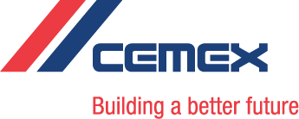
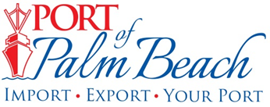

Media Contact Media Contact
Walker Robinson Yaremi Farinas
walker.robinson@cemex.com yfarinas@portofpalmbeach.com
713-722-1799 561-383-4138

For Immediate Release:

CEMEX USA recommissioning cement terminal at Port of Palm Beach
Riviera Beach, FL– (Mar. 5, 2021) –Building materials company and port tenant CEMEX USA announced today it is making improvements to its cement terminal at the Port of Palm Beach as part of the process to recommission the operation later this year and further strengthen its supply chain to service its Florida customers.
CEMEX’s Port of Palm Beach Terminal, which has been inactive for more than 13 years, is currently in its first phase of improvements as part of CEMEX’s overall global growth initiative. The terminal is expected to resume operations this summer, providing a critical addition to CEMEX’s strong Florida network and a cement delivery hub for customers across the state.
CEMEX leases approximately 111,000 square feet of Port owned land for the terminal located west of slip 3 in the port. Silos at the site are designed to hold bulk cement. In preparation of the recommissioning, CEMEX welcomed a shipment of imported product via ship on February 26.
“The resumption of the CEMEX terminal provides the Port with positive economic growth. We expect to see an increase in vessel calls and cargo tonnage once CEMEX’s operation is back in full swing,” said Port of Palm Beach Board Chairman Joseph Anderson.
“Florida continues to grow, and with our network inside the state and globally, CEMEX is well-positioned to support that growth,” said Executive Vice President—Logistics Matt Wild. “We are excited to resume operations at a well-located facility that will enhance our supply chain and benefit our customers by providing an additional option for their cement needs.”
The recent shipment exemplifies Port tenant collaboration with Host Agency being the ship agent. Future shipments are expected to help the Port and CEMEX to further build ties with the community by providing future employment opportunities.
CEMEX is the largest supplier of building materials in the state of Florida offering products including cement, aggregates, ready-mix concrete and concrete block. The company’s Florida network includes three cement plants and more than 10 strategically located cement terminals throughout the state to service customers.

##
About CEMEX USA
CEMEX is a global building materials company that provides high quality products and reliable service to customers and communities throughout the world. Its U.S. network includes 10 cement plants, more than 50 strategically located distribution terminals, 50 aggregate quarries and nearly 270 ready-mix concrete plants.

About Port of Palm Beach
Located in Riviera Beach, the Port of Palm Beach is a full-service, diversified port, offering cruise and cargo services to more than 30 onsite tenants and users. At 162 acres, the Port’s efficiency is unparalleled, processing more than $7 billion in commodities, 2.5 million tons of cargo, and 500,000 cruise passengers annually. As one of the largest employers in Palm Beach County, the Port of Palm Beach and its tenants employ more than 2,850 people. Through the contribution of more than $185 million in business revenue and $17.5 million in tenant-contributed state and local annual tax revenue, the Port of Palm Beach is a large economic engine in South Florida. For more information, visit www.portofpalmbeach.com.

