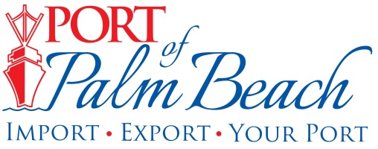
FOR IMMEDIATE RELEASE
October 19, 2020
Contact: Yaremi Farinas, Public Information Officer
yfarinas@portofpalmbeach.com or 561-319-0098

***MEDIA ALERT***

Congressman Brian Mast to visit Port of Palm Beach

WHAT: Port Commisisoners and staff will meet with Congressman Brian Mast to discuss the Port’s plan to expand its rail facility. Congressman Mast, who serves on the U.S. House Committee on Transportation and Infrastructure, played a critical role in the Port being awarded a Port Infrastructure Development Program grant of $13.2 million. Port staff will provide a short visual presentation for Congressman Mast and his staff. We will then escort attendees, including media, into the Port to see our locomotive and rail facility.

WHO: Port of Palm Beach Board Chairman Wayne Richards, Port Executive Director Manuel Almira, Port staff and Congressman Brian Mast.

WHERE: Port of Palm Beach Cruise Terminal
One East 11 the Street.
Riviera Beach, FL. 33404

PLEASE CALL PIO WHEN YOU ARRIVE SO SHE CAN ESCORT YOU TO CRUISE TEMRINAL.

WHEN: Monday, October 19
11:00 AM

About Port of Palm Beach
Located in Riviera Beach, the Port of Palm Beach is a full-service, diversified port, offering cruise and cargo services to more than 30 onsite tenants and users. At 162 acres, the Port’s efficiency is unparalleled, processing more than $7 billion in commodities, 2.5 million tons of cargo, and 500,000 cruise passengers annually. As one of the largest employers in Palm Beach County, the Port of Palm Beach and its tenants employ more than 2,850 people. Through the contribution of more than $185 million in business revenue and $17.5 million in tenant-contributed state and local annual tax revenue, the Port of Palm Beach is a large economic engine in South Florida. For more information, visit www.portofpalmbeach.com.

