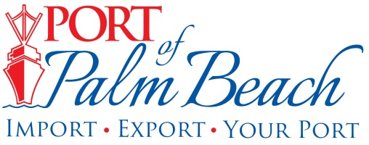
Media Contact
Yaremi Farinas
yfarinas@portofpalmbeach.com
OFFICE: 561-383-4138
CELL: 561-319-0098
Port of Palm Beach awarded federal grant for
rail infrastructure

Riviera Beach, Florida, October 13, 2020- The Port of Palm Beach has been awarded a $13.2 million grant from the U.S. Department of Transportation to expand its intermodal rail freight facility.

The Port is currently very close to meeting its rail freight capacity.
As the growth of containerized cargo continues to rise and the demand for rail reaches a historic high, the Port is focused on future growth.

“Expanding our rail infrastructure will allow the Port of Palm Beach to reach its full potential as a major economic engine by maximizing cargo efficiencies,” said Port of Palm Beach District Chairman Wayne Richards.

The Port Infrastructure Development Program grant will more than double the Port’s intermodal rail capacity from 44,000 TEUs (twenty-foot equivalent units) per year to 95,000 TEUs per year. It will replace old rail with new, relocate the truck interchange and install new radiation portal monitors for increased security, all of which will allow for operations to flow more efficiently.

“Once this project is complete, we expect to see a significant boost in exports and operational efficiencies. The project will create at least 105 direct jobs. Furthermore, expanding our rail infrastructure gives us the opportunity to be better environmental stewards by eliminating 29,000 truck trips per year off I-95. It will in turn, lessen congestion for motorists,” said Manuel Almira, Port Executive Director.
The Port requested $13,224,090 for the project and received the full amount. The Port and private sector will match the funding, bringing the project total to $26.5 million.

“I want to thank the U.S. Department of Transportation, Senator Marco Rubio, Senator Rick Scott and Congressman Brian Mast, for supporting this project. I also want to acknowledge Port Executive Director Almira and Director of Planning and Development Carl Baker, for their efforts in navigating the Port through this process and their coordination with DOT, our elected officials and their staffs. My fellow Commissioners and I look forward to these significant and long-lasting improvements to the Port,” Chairman Richards said.
The Port of Palm Beach was the only Florida seaport to receive a federal grant for port infrastructure.
The Port expects to break ground on the project within a year.

About Port of Palm Beach
Located in Riviera Beach, the Port of Palm Beach is a full-service, diversified port, offering cruise and cargo services to more than 30 onsite tenants and users. At 162 acres, the Port’s efficiency is unparalleled, processing more than $7 billion in commodities, 2.5 million tons of cargo, and 500,000 cruise passengers annually. As one of the largest employers in Palm Beach County, the Port of Palm Beach and its tenants employ more than 2,850 people. Through the contribution of more than $185 million in business revenue and $17.5 million in tenant-contributed state and local annual tax revenue, the Port of Palm Beach is a large economic engine in South Florida. For more information, visit www.portofpalmbeach.com.

