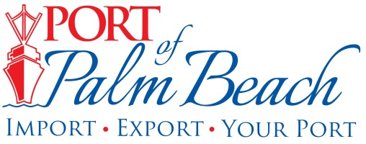
Media Contact
Yaremi Farinas
yfarinas@portofpalmbeach.com
OFFICE: 561-383-4138
CELL: 561-319-0098

Port of Palm Beach District issues Declaration of Emergency

Riviera Beach, Florida, March 20, 2020 - Port of Palm Beach Executive Director Manuel Almira, at the direction of the Board of Commissioners, has issued a Declaration of Emergency in the Port of Palm Beach District.

The Declaration of Emergency has been issued to increase Port of Palm Beach District’s accessibility to resources and allow for flexibility with staffing during the COVID-19 pandemic.

“The Port of Palm Beach District’s priority is always the safety and well-being of our employees, business customers and visitors. Our goal is to sustain essential services at the port with minimal staff, in hopes of not interrupting cargo operations during this difficult time. We understand dozens of businesses, thousands of people and the residents living on the islands in the Caribbean, depend on us remaining operational,” said Executive Director Manuel Almira.

About Port of Palm Beach
Located in Riviera Beach, the Port of Palm Beach is a full-service, diversified port, offering cruise and cargo services to more than 30 onsite tenants and users. At 162 acres, the Port’s efficiency is unparalleled, processing more than $7 billion in commodities, 2.5 million tons of cargo, and 500,000 cruise passengers annually. As one of the largest employers in Palm Beach County, the Port of Palm Beach and its tenants employ more than 2,850 people. Through the contribution of more than $185 million in business revenue and $17.5 million in tenant-contributed state and local annual tax revenue, the Port of Palm Beach is a large economic engine in South Florida. For more information, visit www.portofpalmbeach.com.

