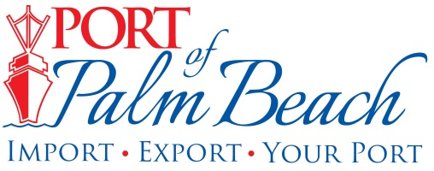
Media Contact
Yaremi Farinas
yfarinas@portofpalmbeach.com
561-383-4138

Port of Palm Beach plugs into innovative electric vehicle research program with free EV charging for employees and port tenants

Riviera Beach, Florida – February 14, 2020- Port of Palm Beach today unveiled new electric vehicle charging stations in its parking lot to encourage employees and port tenants to commute to work in plug-in vehicles. The charging infrastructure is part of Florida Power & Light Company’s new electric vehicle research initiative, FPL EVolution, and Port of Palm Beach employees and tenants are welcome to charge their EVs for free while at work.
“Free charging for electric vehicles is a state-of-the-art employee benefit that aligns with our organization’s sustainability goals and will help motivate more drivers to get behind the wheel of these environmentally friendly cars and trucks,” said Port Executive Director Manuel Almira.
FPL EVolution chargers double as research stations and collect valuable data to help FPL further advance electric transportation in Florida, the third largest EV state in the country.
Workplace charging is one of the most effective ways to promote the adoption of electric vehicles. Employees with access to EV charging at their jobs are six times more likely to drive electric vehicles, according to the U.S. Department of Energy.
“FPL has been at the forefront of advancing affordable clean energy for decades,” said Matt Valle, Vice President of Development. “Through FPL EVolution, we’re partnering with organizations that value sustainability to make Florida a leader in electric transportation.”
FPL plans to install more than 1,000 charging points at more than 100 locations across the state, including large employers, popular destination and Florida Turnpike Service Plazas. The company estimates FPL EVolution could increase the availability of charging stations, which is a key factor in the efficient growth of EVs, by more than 50 percent alone.
About Port of Palm Beach
Located in Riviera Beach, the Port of Palm Beach is a full-service, diversified port, offering cruise and cargo services to more than 30 onsite tenants and users. At 162 acres, the Port’s efficiency is unparalleled, processing more than $7 billion in commodities, 2.5 million tons of cargo, and 500,000 cruise passengers annually. As one of the largest employers in Palm Beach County, the Port of Palm Beach and its tenants employ more than 2,850 people. Through the contribution of more than $185 million in business revenue and $17.5 million in tenant-contributed state and local annual tax revenue, the Port of Palm Beach is a large economic engine in South Florida. For more information, visit www.portofpalmbeach.com.

