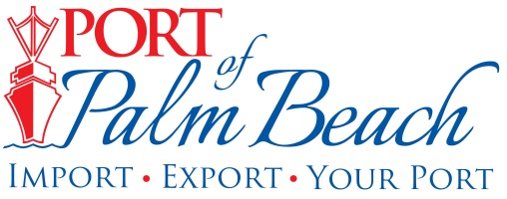
Media Contact
Yaremi Farinas
yfarinas@portofpalmbeach.com
561-383-4138

Maintenance dredging begins in Lake Worth Inlet

Riviera Beach, Florida – November 22, 2019- Maintenance dredging in the Lake Worth Inlet began yesterday.

The hopper dredge Atchafalaya is expected to remove approximately 60,000 cubic yards of sand from the inner and outer harbor channel. Removing the shoal would deepen the sea floor to 37 feet in the inner channel and 39 feet in the outer channel. This will allow some room for shoaling without the sand buildup infringing on our required depths.

Port of Palm Beach Engineer Ronald Coddington explains how this project will benefit a neighboring community.

“While dredging is needed to help keep the movement of cargo being imported and exported through the Port of Palm Beach, this project is also rebuilding the eroding beach in the town of Palm Beach,” Coddington said.

The sand will be pumped as far as half a mile down the beach. Coddington said it is safe to place the beach compatible sand on Palm Beach because turtle nesting season has ended.

The project is expected to be complete in about two weeks.

The U.S. Army Corps of Engineers funded the maintenance dredge that usually takes place once a year.

This maintenance dredging project is separate from the emergency dredging that took place in October.

About Port of Palm Beach
Located in Riviera Beach, the Port of Palm Beach is a full-service, diversified port, offering cruise and cargo services to more than 30 onsite tenants and users. At 162 acres, the Port’s efficiency is unparalleled, processing more than $7 billion in commodities, 2.5 million tons of cargo, and 500,000 cruise passengers annually. As one of the largest employers in Palm Beach County, the Port of Palm Beach and its tenants employ more than 2,850 people. Through the contribution of more than $185 million in business revenue and $17.5 million in tenant-contributed state and local annual tax revenue, the Port of Palm Beach is a large economic engine in South Florida. For more information, visit www.portofpalmbeach.com.

