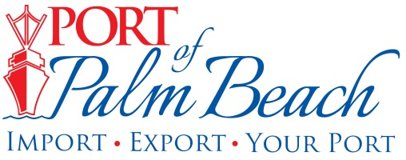
Media Contact
Yaremi Farinas
yfarinas@portofpalmbeach.com
561-383-4138

Port of Palm Beach joins mission to protect Florida’s coral reefs

Riviera Beach, Florida – October 21, 2019- This month, the Port of Palm Beach joined the Southeast Florida Coral Reef Initiative. SEFCRI’s mission is to develop an effective strategy to preserve and protect southeast Florida’s coral reefs.

“The SEFCRI brings together a group of about 70 individuals who are in marine science and related environmental projects, to put their ideas together to create those strategies to look for better water quality and enhance our coral reef environment,” said Port Engineer Ronald Coddington.

Joining SEFCRI helps the Port of Palm Beach strengthen its commitment to the protection of our marine environment.

“The Port of Palm Beach is very active in coral protection. Our coral protection measures in the port included the relocation of more than 1,000 corals during our most recent bulkhead reconstruction project,” Coddington said.

Coddington, who was a former vice-chair for SEFCRI, wants the community to know how important coral reefs are to South Florida. They support fisheries and create jobs and businesses.

“To give you an idea, coral reefs are worth something like $375 billion impact around the world. Florida alone has an economic value of a little over $8 billion. We contribute about $4.4 billion dollars a year in jobs and goods that are sold related to our coral reefs,” Coddington said.

About Port of Palm Beach
Located in Riviera Beach, the Port of Palm Beach is a full-service, diversified port, offering cruise and cargo services to more than 30 onsite tenants and users. At 162 acres, the Port’s efficiency is unparalleled, processing more than $7 billion in commodities, 2.5 million tons of cargo, and 500,000 cruise passengers annually. As one of the largest employers in Palm Beach County, the Port of Palm Beach and its tenants employ more than 2,850 people. Through the contribution of more than $185 million in business revenue and $17.5 million in tenant-contributed state and local annual tax revenue, the Port of Palm Beach is a large economic engine in South Florida. For more information, visit www.portofpalmbeach.com.

About Southeast Coral Reef Initiative
SEFCRI, or the Southeast Florida Coral Reef Initiative, is a local action strategy for collaborative action among government and non-governmental partners to identify and implement priority actions needed to reduce key threats to coral reef resources in southeast Florida, which includes Miami-Dade, Broward, Palm Beach and Martin counties. For more information, visit https://southeastfloridareefs.net/.

