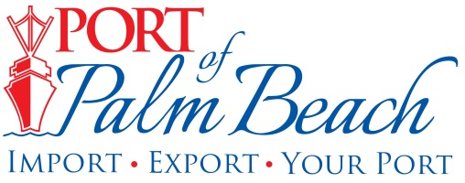
Media Contact
Yaremi Farinas
yfarinas@portofpalmbeach.com
561-383-4138

Relief supplies collected by Palm Beach County Cares shipped from Port of Palm Beach

Riviera Beach, Florida – October 21, 2019-

On Monday, 26 pallets of donated supplies were loaded onto a cargo ship named the Duke of Top Sail. The supplies were collected by a volunteer group, Palm Beach County Cares, which was co-founded by Port of Palm Beach Commission Chair Katherine Waldron.

“Palm Beach County Cares continues to ship supplies to the affected communities in the Bahamas. We are proud to be partnering with the Duke of Top Sail and Gulfstream Line Inc. and appreciate their efforts in helping PBCC achieve its mission,” Chair Waldron said.

The supplies are expected to arrive in Marsh Harbour Tuesday afternoon.

About Port of Palm Beach
Located in Riviera Beach, the Port of Palm Beach is a full-service, diversified port, offering cruise and cargo services to more than 30 onsite tenants and users. At 162 acres, the Port’s efficiency is unparalleled, processing more than $7 billion in commodities, 2.5 million tons of cargo, and 500,000 cruise passengers annually. As one of the largest employers in Palm Beach County, the Port of Palm Beach and its tenants employ more than 2,850 people. Through the contribution of more than $185 million in business revenue and $17.5 million in tenant-contributed state and local annual tax revenue, the Port of Palm Beach is a large economic engine in South Florida. For more information, visit www.portofpalmbeach.com.

