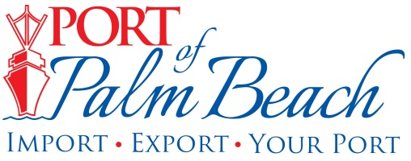
Media Contact
Yaremi Farinas
yfarinas@portofpalmbeach.com
561-383-4138

Grand Classica’s inaugural sailing to Nassau

Riviera Beach, Florida – October 11, 2019 – On Saturday, October 12th, Bahamas Paradise Cruise Line’s Grand Classica will set sail on its inaugural voyage to Nassau, Bahamas from the Port of Palm Beach.

“After ongoing discussions with the Bahamas Ministry of Tourism, we are thrilled to have been given official approval to resume leisure cruises to Grand Bahama Island, as well as to introduce Nassau as a second destination for our guests,” said Oneil Khosa, CEO of Bahamas Paradise Cruise Line.

The cruise line’s Grand Celebration will continue sailing to Freeport.

About Port of Palm Beach
Located in Riviera Beach, the Port of Palm Beach is a full-service, diversified port, offering cruise and cargo services to more than 30 onsite tenants and users. At 162 acres, the Port’s efficiency is unparalleled, processing more than $7 billion in commodities, 2.5 million tons of cargo, and 500,000 cruise passengers annually. As one of the largest employers in Palm Beach County, the Port of Palm Beach and its tenants employ more than 2,850 people. Through the contribution of more than $185 million in business revenue and $17.5 million in tenant-contributed state and local annual tax revenue, the Port of Palm Beach is a large economic engine in South Florida. For more information, visit www.portofpalmbeach.com.

