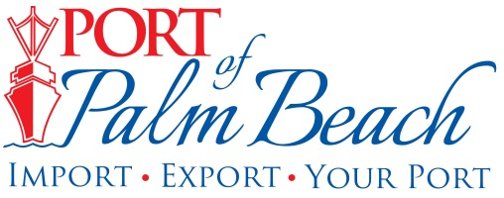
Media Contact
Yaremi Farinas
yfarinas@portofpalmbeach.com
561-383-4138

Port of Palm Beach waives cargo fees for Bahamas relief efforts

Riviera Beach, Florida – September 5, 2019 – On Thursday morning, Port of Palm Beach Executive Director Manuel Almira announced the port will waive all cargo-related fees for donated humanitarian relief supplies that are being shipped to the Bahamas following Hurricane Dorian.

The Port of Palm Beach has several tenants who regularly ship directly to the affected islands in the Bahamas.

“Our hearts go out to our neighbors in the Bahamas who have lost nearly everything. We know right now they are in need of food, water and other supplies. By waiving cargo related fees, we can ensure the Bahamian people receive the supplies they desperately need,” said Port Executive Director Manuel Almira.

About Port of Palm Beach
Located in Riviera Beach, the Port of Palm Beach is a full-service, diversified port, offering cruise and cargo services to more than 30 onsite tenants and users. At 162 acres, the Port’s efficiency is unparalleled, processing more than $7 billion in commodities, 2.5 million tons of cargo, and 500,000 cruise passengers annually. As one of the largest employers in Palm Beach County, the Port of Palm Beach and its tenants employ more than 2,850 people. Through the contribution of more than $185 million in business revenue and $17.5 million in tenant-contributed state and local annual tax revenue, the Port of Palm Beach is a large economic engine in South Florida. For more information, visit www.portofpalmbeach.com.

