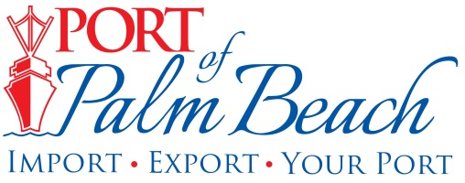
Media Contact
Yaremi Farinas
yfarinas@portofpalmbeach.com
561-383-4138

Port of Palm Beach Reopens

Riviera Beach, Florida – September 4, 2019 – The Port of Palm Beach reopened Wednesday, Sept 4th, at 10:30 a.m. to both cargo operations and vessel traffic. This morning a contracted survey company and a captain with the USCG Port Sector Miami, assessed the Lake Worth Inlet and found it was safe to resume marine traffic.

With some of our tenants serving the Bahamian islands, they are working on figuring out what’s happening in the Bahamas, with the goal of providing disaster relief efforts as soon as possible.

We will let you know of organized relief efforts involving the port as soon as the details become available.

About Port of Palm Beach
Located in Riviera Beach, the Port of Palm Beach is a full-service, diversified port, offering cruise and cargo services to more than 30 onsite tenants and users. At 162 acres, the Port’s efficiency is unparalleled, processing more than $7 billion in commodities, 2.5 million tons of cargo, and 500,000 cruise passengers annually. As one of the largest employers in Palm Beach County, the Port of Palm Beach and its tenants employ more than 2,850 people. Through the contribution of more than $185 million in business revenue and $17.5 million in tenant-contributed state and local annual tax revenue, the Port of Palm Beach is a large economic engine in South Florida. For more information, visit www.portofpalmbeach.com.

